

**FINAL ASSESSMENT**

**FINAL ASSESSMENT**

**COURSE : SOFTWARE QUALITY ASSURANCE**

**COURSE CODE : BCS3263**

**COURSE COORDINATOR : ROSLINA MOHD SIDEK**

**DATE : 16 DEC 2024 – 13 JAN 2025**

**DURATION : 4 WEEKS**

**SESSION/SEMESTER : SESSION 2024/2025 SEMESTER I**

**INSTRUCTIONS TO STUDENTS:**

1. This assessment paper consists of **TWO (2)** questions. Answer **ALL** questions.
2. All answers to a new question should starts on a new page.
3. All calculations and assumptions must be clearly stated.
4. This evaluation is individual work.
5. Please use IEEE citation format.
6. Submission Naming Convention: Student ID_Name

**APPENDIX:**

Appendix 1

Previously, students have completed the assigned project in group. The project was objectively focus on a small to medium-sized enterprise (SME). Based on the project, each group successfully developed and finalized the assigned task, integrating at maximum FOUR (4) modules to improve quality attributes.

For this assessment, project group will be assigned by the Lecturer and you have to select a module within the project group and have to perform task as Quality Assurance Personnel to access the other students’ project. Each member must select one module from the exchanged work to analyze and discuss.

Your analysis and discussion for this assessment must be alignment with the ISO/IEC 25010 (Figure 1). The focused must on the usability quality attribute. The selected quality attribute is a critical in software development. Your evaluation should provide a thorough analysis of the chosen module, including specific recommendations for improvement.

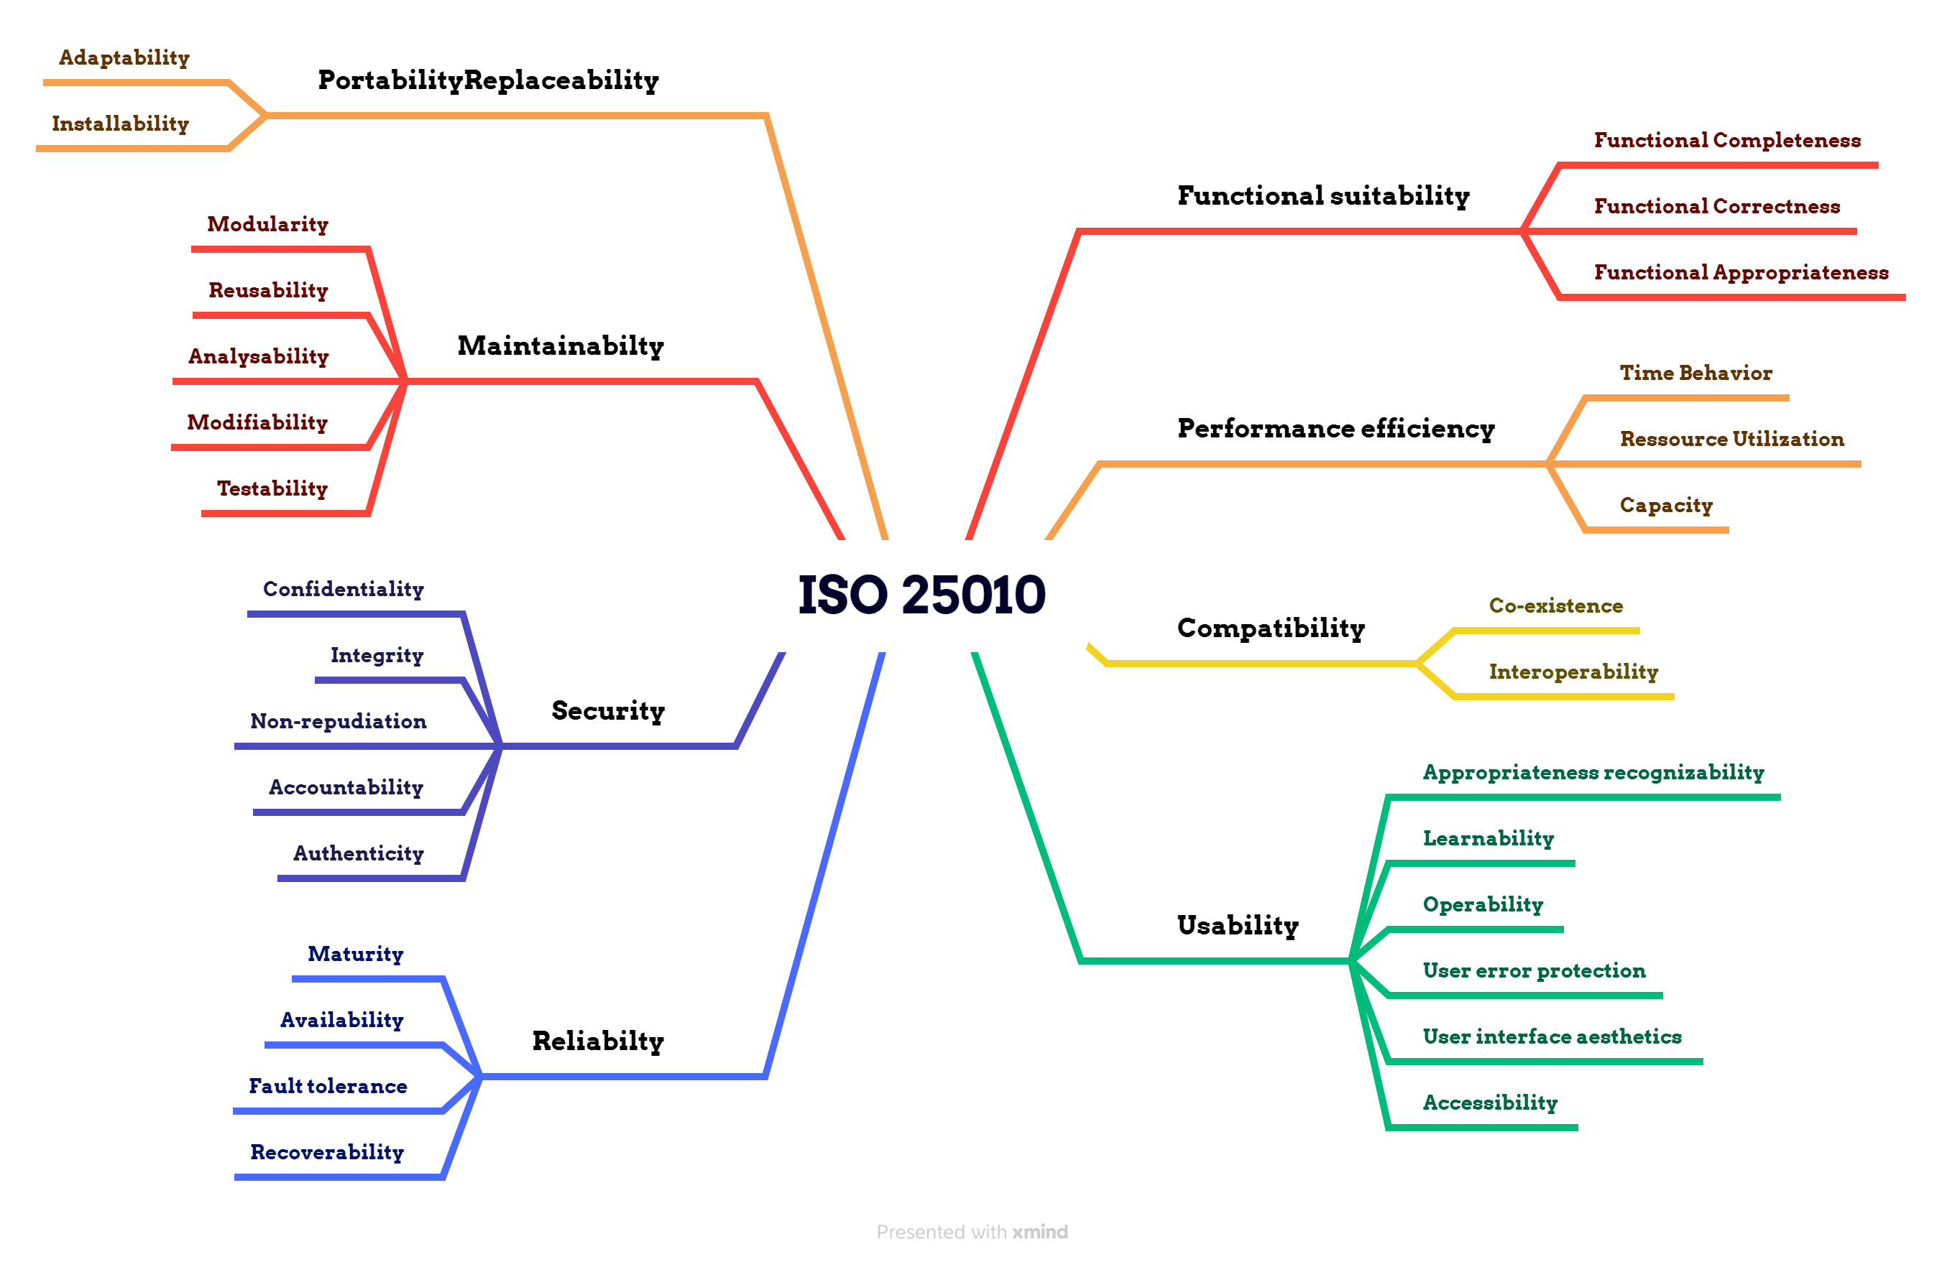

**Figure 1.** **ISO/IEC 25010**

**QUESTION 1**

As a quality assurance personnel, analyze the given module for the project by referring to the Quality standard.

1. Explain thoroughly the **MAINTAINABILITY** in the module that is related to the Quality standard.

[**10 Marks**]

[C4]

1. Analyze at least **ONE (1)** sub-attribute for **MAINTAINABILITY** for the selected module.

**[20 Marks]**

**[C5]**

**QUESTION 2**

Prepare a detailed report based on the findings from **QUESTION 1 (b)**, focusing on the assessment of maintainability. Ensure that your report follows **IEEE citation** format and incorporates relevant information from **Appendix 1**.

**[70 marks]**

**[C4]**

**END OF QUESTION**

**APPENDIX 1**

**1.0 Abstract**

**- (intro, problem, method, result, conclusion)**

**2.0 Introduction**

**- (issue, problem, solution, quality related, citation)**

**3.0 Literature review**

**- (current measure, study)**

**4.0 Method to review**

**- (how to measure, metric, citation, explain, sources)**

**5.0 Dataset**

**- for calculation purposes.**

**6.0 Result**

**7.0 Conclusion**

**8.0 Reference**